**Volcanoes Notes**

* Volcanoes destroy. Volcanoes are a major geological hazard to people and property.
* Volcanoes create new mineral and energy resources and land. Many of our mineral resources are created by igneous processes. Soil formed from volcanic rock is usually very fertile (Snake River Plain of southern Idaho).
* Volcanoes give us clues about what is inside the earth and how the earth works. Vulcan’s Throne
* Volcanoes form near plate boundaries, and ocean crust is made mostly of igneous rock. Spreading centers and volcanic arcs are located near plate boundaries. The volcanic arcs can be hazardous locations!

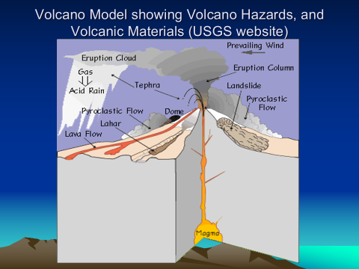

**Review of Igneous Rocks – Volcanoes are Made of Igneous Rocks**

* Igneous rocks originate from magma. The magma is made up of the rock forming or silicate (SiO2) minerals.
* Two main categories of Igneous Rocks
  + **Intrusive** – magma cools slowly deep inside the earth and crystals are large (can be seen). Granite is an example
  + **Extrusive** – magma cools fast on or near the earths surface and crystals are small (can’t be seen without a microscope). Basalt is an example. Shield volcanoes are made mostly of basalt.
    - **Pyroclastic** – subcategory of extrusive that includes small solid chunks of magma in the form of cinders, ash and other materials blown out of volcano in an explosive type manner. This is the main type of material erupted from

**Properties of Magma**

* The properties of magma and type of rock depend on **magma composition**. Type of volcano is determined by the type of magma. Magma is mostly molten silicate minerals.
* The two main types of magma are **silicic and mafic.**
* **Viscosity** describes how a substance flows or how sticky it is. Water has a low viscosity (not sticky) compared with cold honey which has a higher viscosity. Temperature plays a role, i.e., magma flows and rock doesn’t.
* **Gases** – magma contains about 1-5% gas by volume (dissolved and trapped like CO2 in can of soda). The way a soda opens depends on its environment (hot and shaken or cold and still). It’s similar for magma.
* **Pressure – Hot magma** is less dense (lava lamp) than the rocks surrounding it, so it rises very slowly inside the earth. As it rises, it is under pressure from the weight of the overlying rock and from gas inside the magma. Because silicic magma is “sticky” and doesn’t flow easily, high pressures build. When magma gets close to the surface and finds an outlet to the surface, the confining pressure drops and the gases inside the magma expand. As the gases expand, the volume of the material increases, building more pressure, until an explosive eruption occurs (Mt. St Helens example).
* **Temperature** – different magmas have different temperatures depending on magma composition. Hotter magmas contain minerals that melt at higher temperatures. Temperature also affects viscosity…higher temp means more flow.

Plate Tectonic Origin of Volcanoes

* Island Arc Volcanoes – Alaska, Japan, Indonesia - Convergent
* Hot-spot volcanoes – Hawaii
* Ocean ridge volcanoes - Divergent
* Continental Margin volcanoes – Mt. St. Helens, Andes - Convergent
* Continental Rift – Africa – Divergent
* **Most v**olcanoes located on land/above water are located near convergent plate boundaries. The main product erupted is **pryoclastic materials** such as ash, cinders pumice and some lava. The magma is **andesite/rhyolite** in composition**.**
* Divergent boundaries –Hundreds of square kilometers of basalt is erupted each year at spreading centers. Liquid magma (basaltic lava) is the main product.
* **Hotspots** - Islands like Hawaii located above hotspots are also made of **basalt**. Huge volumes of basalt are erupted. The island of Hawaii is the one of the largest mountains on earth (seafloor to top).

**How Geologists Study Volcanoes – Process and Deposit**

* Principles of uniformitarianism, superposition, unconformities and cross cutting relations apply in the study of volcanic deposits.
* Model shows main processes. Each process leaves a record or deposit (pile of rock)
* We can’t travel back in time and see eruptions, but we can study the deposits.
* By understanding how active volcanic processes we can study deposits to learn about past volcanic events.

Volcanic Materials

* **Lava** –basalt is the most commonly erupted volcanic material - ocean basins
* **Pyroclastics** “pieces of fire, ” this includes solids such as ash, cinders and larger pieces of solid magma. Most common material volcanoes that erupt on land.
* Hot solids mixed with gas ejected from a volcano.
* Composite type volcanoes are the most destructive to humans.
* Pyroclastic materials include: ash, cinders and larger materials. Mixed with gases and the whole mixture is heavier than air so it flows. Pryoclastic flows can travel very fast 100 km/hr and very far (10s of kilometers).
* Air fall – layers of ash with a thickness related to the amount of material erupted & distance from the volcano
* http://www.youtube.com/watch?v=bEOhPeeUJws
* Flow – layers of ash, cinders and hot materials mixed with gas. These materials are denser than air and flow down the sides of a volcano. The deposits fill in the low spots around a volcano.
* http://www.youtube.com/watch?v=HpNWLCmXyTE
* Lahars - mud, rock and debris deposits (mudflows) made of volcanic materials. Armero, Columbia.
* http://www.youtube.com/watch?v=bt05FIIZPgM
* Pumice – frothy, high volume, low mass magma (fudge boils over)

Study of a Volcano/Process and Deposit

1. Map and Describe the deposits (thickness, type, origin, lateral extent)
2. Organize the Deposits by Age including unconformities
3. Correlate – find lateral extent and size of eruptions
4. Find Radiometric or real age (carbon dating etc

Stratigraphic Column represents all rocks in a certain area organized by age

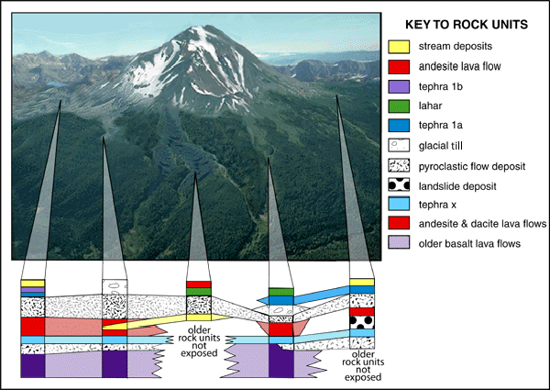

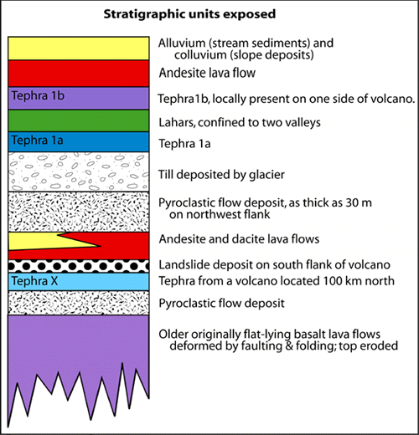

**Three Types of Volcanoes**

Most volcanoes have a central vent from which most of the lava or pyroclastics come to the surface. The volcano forms around the central vent. The type of volcano and its form depends mostly on the type of magma, BUT NO TWO VOLCANOES ARE ALIKE!!!

1. Cinder Cone – relatively small made of cinders and not much lava – St George – can form with any type of magma.
2. Strato or Composite Volcano – large, made of ash, cinders, pyroclastics and silicic lava – Mt. St. Helens, Mt. Fuji, Vesuivus etc. Near **convergent plate** boundaries
3. Shield Volcano – 30 mles across, thousands of mafic or basaltic lava flows like Hawaiian type – Hotspots. Hawaii, Maui, Ouahu etc., are made of several shield volcanoes that have merged to form islands. The older islands are small because they are eroded.
4. Fissure eruption – Not a volcano with a central vent, large cracks in the earth from which gigantic volumes of basalt are erupted. Examples divergent boundaries and areas such as the Columbia Plateau of Oregon and Washington.

**Intrusive Igneous Rocks and Bodies of Rocks (where gold, silver, zinc, lead etc. come from)**

* Most magma stays under the surface and intrusive igneous rocks make up a large amount of the continental crust.
* Batholith – a mountain range sized mass of intrusive rock (granite). Sierra Nevada batholith and central Idaho Batholith etc. These represent the locations of old convergent boundaries and volcanic chains that are now eroded away.
* Stock – mountain sized mass of intrusive rock/granite, Kennecott, Park City and Alta stocks
* Dike and Sill – smaller tabular bodies of igneous rock - dikes cut vertically across other rocks and sills are injected horizontally between other rock bodies.

**Tuff Cones**

* A **tuff cone** is formed when basaltic magma erupts into a lot of water. In this case groundwater. Diamond Head, Hawaii is the most famous example of a tuff cone. Pavant Butte is a 16,000 year old, 275m high, 3km wide, tuff cone that erupted into Lake Bonneville. The lake was about 85m deep at the time.

**Geysers**

Geysers are rare. 1000 known Geysers & 50 Geyser fields worldwide

Three components must be present for geysers to exist:

* + an abundant supply of water,
  + an intense source of heat
  + unique plumbing.
  + Water is common, heat can come from any volcanic activity, but the plumbing is critical. For water to be thrown into the air, geyser plumbing must be water- and pressure-tight.
  + Most geyser systems are made of the volcanic rock **RHYOLITE**. Rhyolite is high in silica, which can deposit a water-tight seal.
  + The mixture of water, volcanic heat, and plumbing is exceptional at Yellowstone National Park. **Over one-half of the world's geysers are located within the park's boundaries**.

**Craters and Calderas**

* + A **crater** is a depression at the top of the volcano. It marks the location or top of the central vent.
  + A **caldera** is a large depression that results when the top of a volcano collapses. It collapses because so much magma is erupted from under the volcano that the volcano can’t support itself.
  + Crater Lake in Oregon is a caldera. Crater Lake is 1943 feet deep and is the 7th deepest lake in the world.
  + There are calderas in the Yellowstone area that are 10s of miles across and represent the largest eruptions ever mapped. World’s largest geological hazard next to a big meteorite…..

**How Big are Volcanic Eruptions?**

* About 60 volcanoes erupt annually
* How do volcanologists measure eruption size? No single feature determines size, but there is an eruption magnitude scale - called the **Volcanic Explosivity Index or VEI.**
* Huge eruptions are rare

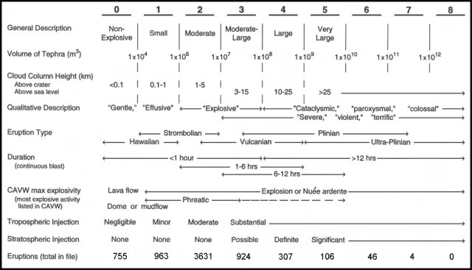

Vesuvius in 79 AD one of the most famous and well known erutpions

Pliny the Younger the First Vulcanologist

Naples one of the most dangerous cities in the world due to geologic (volcanic) hazards

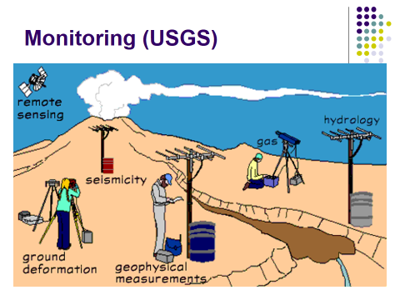

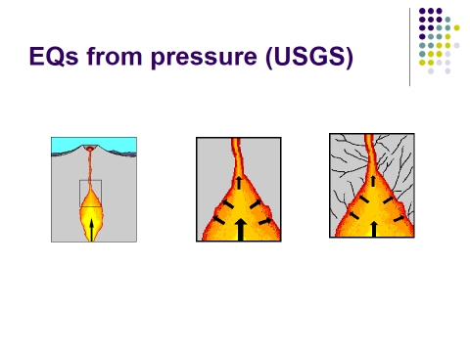

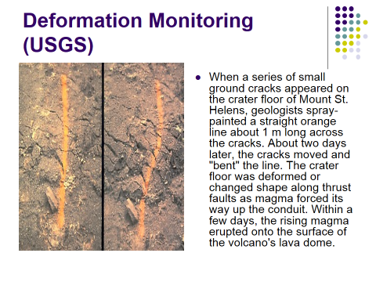

**Volcanoes and EQs**

* **Moving Magma and Volcanic Fluids Trigger Earthquakes**
* **Magma rises into reservoir beneath volcano**
* **Rising magma and volcanic gases exert pressure**
* **High pressure causes rocks to break, triggering earthquakes**
* Earthquake activity beneath a volcano almost always increases before an eruption because magma and volcanic gas must first force their way up through shallow underground fractures and passageways. When magma and volcanic gases or fluids move, they will either cause rocks to break or cracks to vibrate. When rocks break high-frequency earthquakes are triggered. However, when cracks vibrate either low-frequency earthquakes or a continuous shaking called volcanic tremor is triggered.
* Most volcanic-related earthquakes are less than a magnitude 2 or 3 and occur less than 10 km beneath a volcano. The earthquakes tend to occur in swarms consisting of dozens to hundreds of events. During such periods of heightened earthquake activity, geologists work 24-7 to detect subtle and significant variations in the type and intensity of seismic activity and to determine when an eruption is occurring, especially when a volcano cannot be directly observed.

**Gas Monitoring**

* Geologists know that gases dissolved in magma provide the driving force of explosive volcanic eruptions, but only recently have new techniques permitted routine measurement of different types of volcanic gases released into the atmosphere. Sulfurous volcanic gas and visible steam are usually the first things people notice when they visit an active volcano. A number of other gases also escape sight unseen into the atmosphere through hot **fumaroles**, active vents, and porous ground surfaces. The gases escape as magma rises toward the surface, when it erupts, and even as it cools and crystallizes below ground.
* A primary objective in gas monitoring is to determine changes in the release of certain gases from a volcano, chiefly carbon dioxide and sulfur dioxide. Such changes can be used with other monitoring information to provide eruption warnings and to improve our understanding of how volcanoes work. In recent years, we have directed increased attention toward volcanic gas emissions because of the newly appreciated hazards they sometimes pose and their effects on the Earth's atmosphere and climate.

